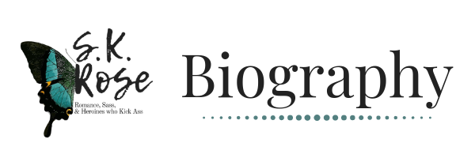

S.K. Rose lives in the hellish desert of Arizona with her newly appointed husband and two obnoxious cats. When she’s not writing, Rose enjoys reading, gaming, swearing like a drunk sailor, collecting swords, and obsessing over the magnificent sea creature: the octopus. Crowned the Guilt is her first novel with plans for many more to come.

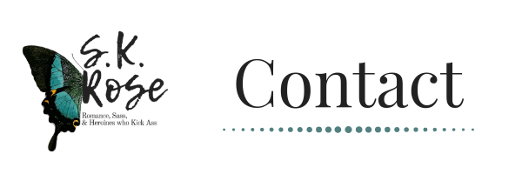
authorskrose@gmail.com

https://www.facebook.com/AuthorSKRose/

https://www.instagram.com/authorskrose/

https://twitter.com/authorskrose
.

https://www.goodreads.com/authorskrose

https://www.bookbub.com/authors/s-k-rose

https://www.skrose.com/

https://amzn.to/2DCpbWt

https://www.skrose.com/newsletter

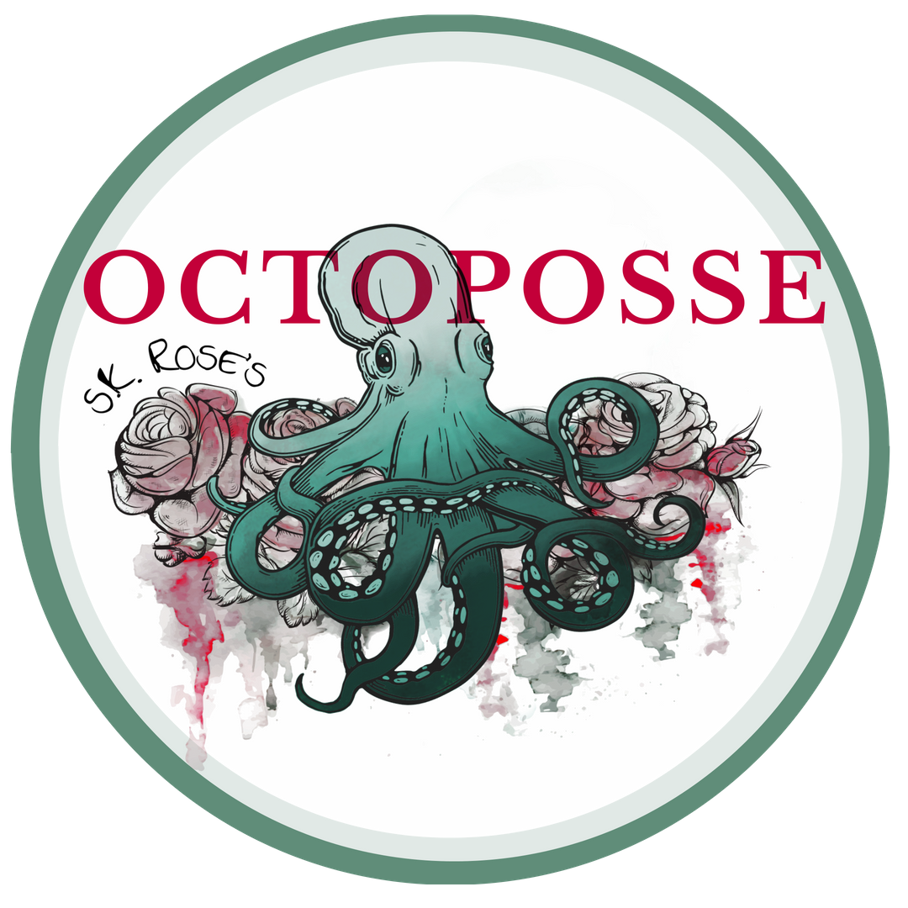https://www.facebook.com/groups/octoposse/

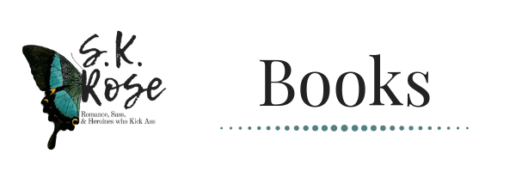
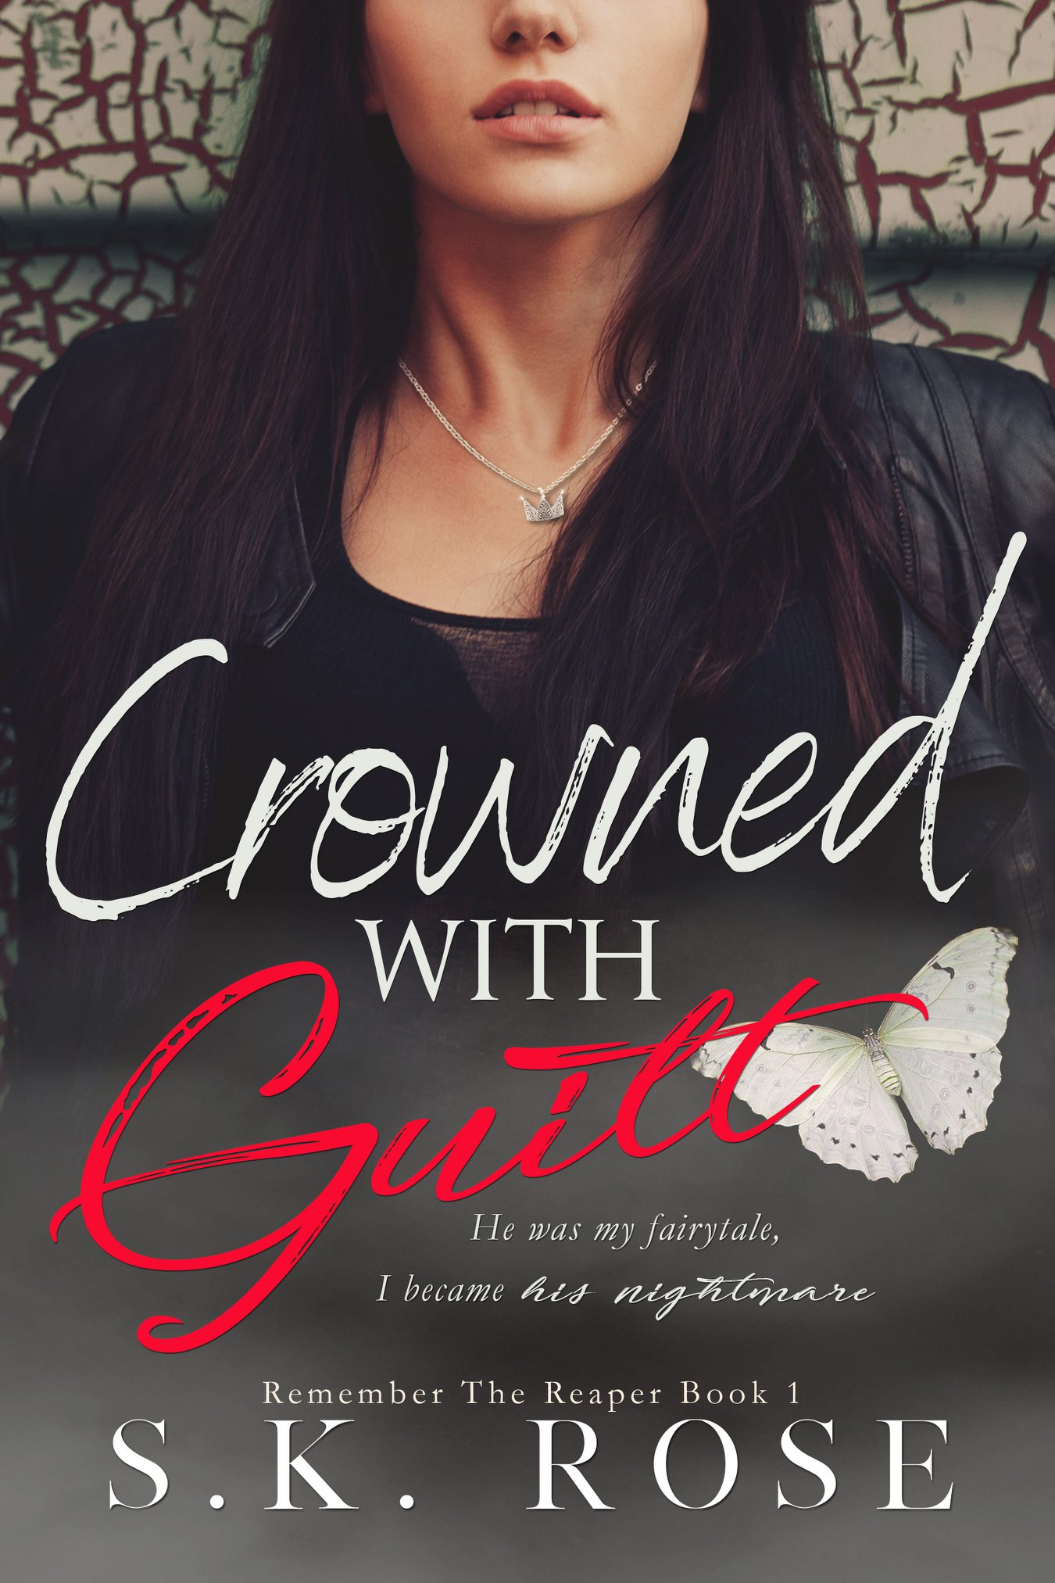
Title
Crowned with Guilt: Remember the Reaper Book 1

Synopsis
As a child, I discovered a castle.
It became a sanctuary from the nightmare that was my life, but my fairytale truly began when he found me.
The boy with green eyes and crooked smile.
The boy with stories and an imagination that could take us far, far away.

In our castle he was the prince, and I the princess.
For the first time in my life I was safe, happy.
I was loved.
But every fairytale has a villain, ours would be no different.
I just never expected the villain to be me.

Amazon Link (KU):
http://hyperurl.co/amazoncwg
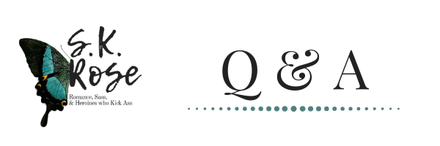
What books have most influenced your life?
The Dark Tower series by Stephen King is the first series that really opened my eyes about how powerful a story can be, it moved me in a way I have difficulty putting into words. The next series would be No Regrets by Aimee Noalane, it is this incredible story that truly set things in motion for me. For the first time in my life I thought “Maybe I can do this too.”

How do you develop your plots and characters?
My character and story boards are very visual and generally intertwined. I pull lots of images from Pinterest that inspire me and construct them with a mess of notes that somehow come together to create the twisting path that my story will take. That being said, as I write so many things end up changing by the end it ends up being quite a different monster.

What is the hardest part of writing a book?
The pressure I put on myself that everything needs to be perfect, to the point that I will rework a single sentence a hundred times over with a touch of obsession.

If you couldn’t be an author, what would your ideal career be?
Maybe a publisher, reading has always been one of my favorite passions and how awesome would it be to read through manuscripts to find and polish the diamonds in the rough?

What is your preferred method to have readers get in touch with or follow you (i.e., website, personal blog, Facebook page, here on Goodreads, etc.) ?
My Facebook group “SK’s Octoposse” is really fun and active place so I do interact in there quite a bit. Besides that I have an awesome website that went live not long ago and is another great platform to stay updated.

Who are your favorite authors?
Wow, hard question. As I previously mentioned his work, Stephen King will always have a special place in my heart. To name a few more I also adore Tad Williams, Pierce Brown, Margaret Weis, Tracy Hickman, Aimee Noalane, K Webster, C.M. Owen and etc. etc. the list goes on for DAYS.

What motivated you to become an author?
I wrote a lot as a kid, mostly poetry, but never thought I had it in myself to write a whole book. It wasn’t until I met my husband and he pushed me to follow my dream that I finally got the courage to try.

Do you remember the first story you ever wrote?
It was weird short story about a shapeshifter girl I think? I don’t know but I remember it being very odd haha.
Where is your favorite place to write?
Any public café, something about being surrounded by strangers with headphones popped in my ears and loud music draining out all the people noises is oddly cathartic and helps me focus.
How long does it/did it take to write start to finish
With Crowned with Guilt it took me a little less than a year with a few breaks here and there to play my wedding.

How would you categorize your books?
The duet I am working on can fit into a few different subgenres of romance. It’s a bit dark, and a lot angsty. Although the first book Crowned with Guilt could be considered Young Adult, the second one? Not so much haha.

Who was your favorite character to write and why?
Tessa Kinsley, I put so much of myself in her that she became this weird extension of my personality.

If your characters all got together for drinks, what kind of things would they say about you? Call me evil, much like my readers do - hah!

What's your go to writing snack?
Ice tea and anything I can crunch on. I do have a pretty extreme weakness for kit kats. . .

Do you do in-depth research when it comes to sex scenes?
Well I have to make sure it all feels as good as it sounds. . . hehe

What do you do to get out of a writer's block?
I take a break, then re-read a few chapters back, after that I can almost always get back in the right headspace to move forward with the story.

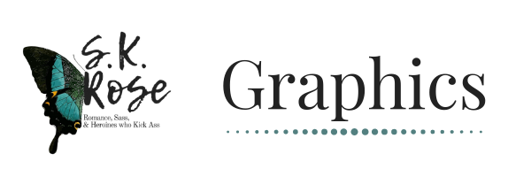
Author Graphics

Crowned With Guilt Graphics

